Ansible AAP integrates with VMware vCenter for VM provision automatically
In this article, we will introduce the steps and playbooks/job templates for VM automatically provision by Ansible AAP and VMware integration.
We will design a automation workflow to performing operation below:
1, Automatically clone Linux(RHEL) vm from existing VM template on VMware.
2, Cloned VM auto power on and apply network setting as demand.
3, Apply security baseline on provisioned vm.
4, Email notify administrator when above job done.

Prerequisites：
- Ansible Automation Platform 2.5+ installed
- EE for VMware integration has been created
- VM template(RHEL 8.x) already existed on vmware esxi server with vmware-tools installed
- Admin or privileged user with username & password on VMware vCenter
- Email setting parameters is ready(including mail server, port, sender username & password and recipient list)
- Organization, Project has been created on AAP UI

The environment for vm provision automatically：
Role | Hostname | IP | Comment
AAP Controller 2.5 on RHEL 9.5 | aap25-jw.example.com | 10.66.208.239
VMware vCenter 7.0+ |  | 10.71.18.138
A Linux(RHEL 8.10) vm template
with vmware-tools and perl installed

Preparation：

- Check VM template on vmware, make sure vmware-tools and perl installed：
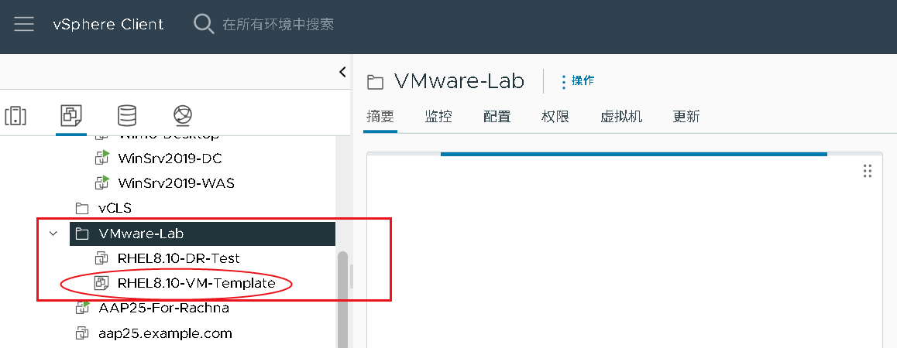
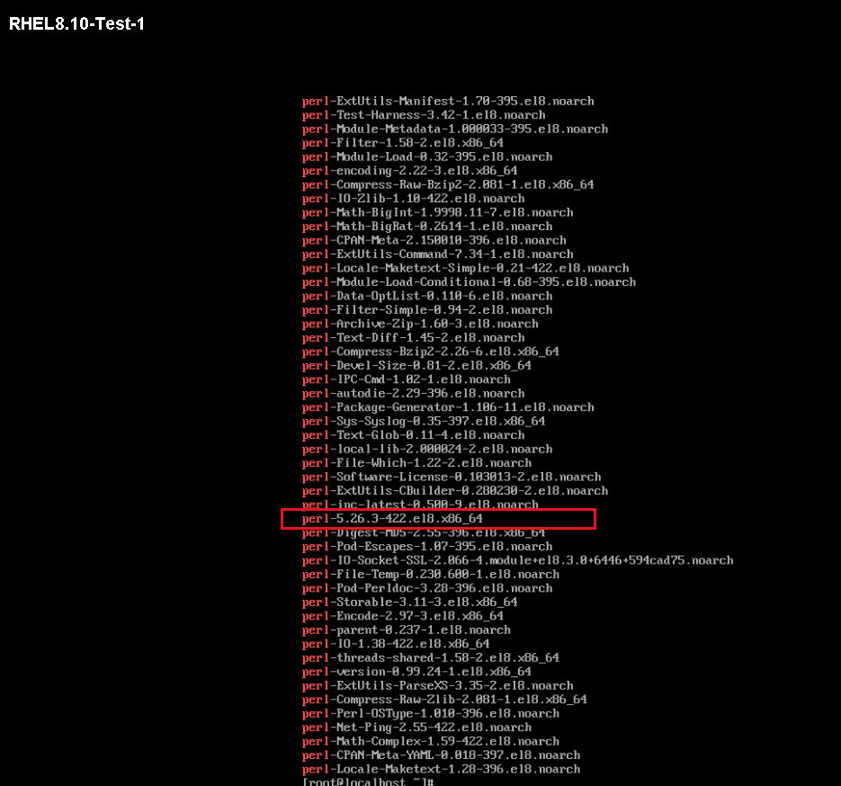
Note:
Below is the more detail information about my vm template:
Name: RHEL8.10-VM-Template
Location: in VMware folder “VMware_Lab”, and VMware datacenter “Beijing_dc02”

- Based on vCenter admin username and password create credential：
In my lab, vCenter IP is 10.71.18.138, admin username and password is：
administrator@vsphere.local
Your_password

So create a credential with name “vc_credential” and type “VMware vCenter” as following:
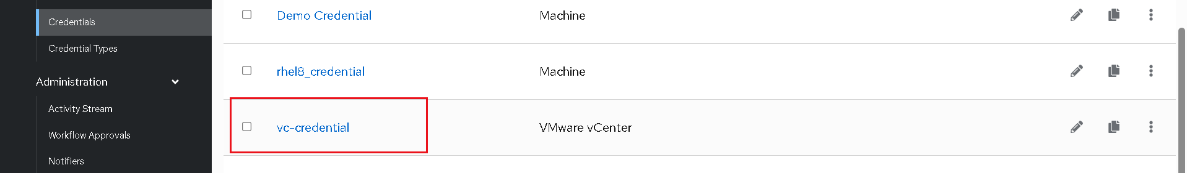
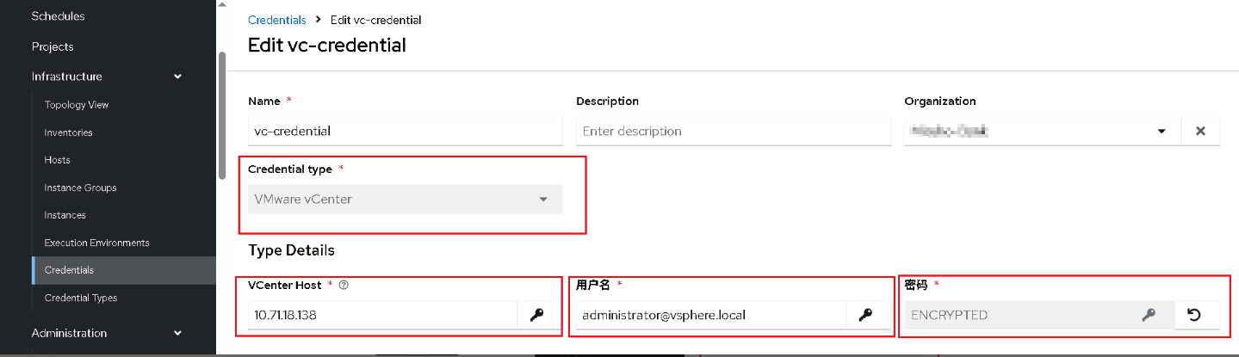

Since calling vCenter to execute VMware modules and collections is generally done on AAP, playbook tasks are usually executed locally on AAP via delegate_to: localhost or aap. Therefore, there is no need to create an inventory for VMware on the AAP UI.

- Ensure that the AAP controller's project directory contains a complete ansible.cfg file (encapsulated within a custom EE), an inventory file, and a complete collection (for local testing).
[admin@aap25-jw example-project]$ cat ansible.cfg
[defaults]
inventory = ./inventory
remote_user = admin

[privilege_escalation]
become = true
become_method = sudo
become_user = root
become_ask_pass = false

- Setup notifier on AAP：
Create a email notifier on AAP Web UI as example blow:
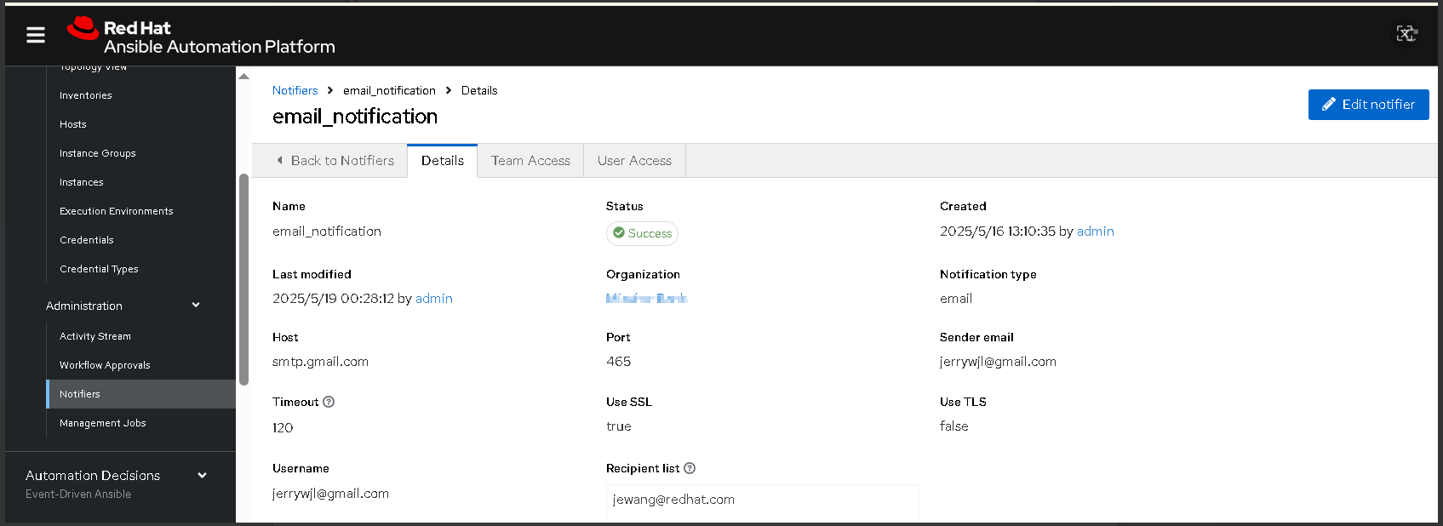

Steps for create the Automation Workflow：

- Create the first playbook, linux_vm_deploy.yml, content of playbook as below:
[admin@aap25-jw example-project]$ cat linux_vm_deploy.yml
---
- name: Deploy and configure RHEL VM on VMware
hosts: localhost
collections:
- community.vmware
vars:
vcenter_hostname: ""
vcenter_username: ""
vcenter_password: ""
data_center: ""
virtual_network: ""
vm_template: ""
vm_name: ""
vm_folder: ""
network_interface: ""
vm_ip: ""
vm_netmask: ""
vm_gateway: ""
vm_dns:
- ""
- ""
vm_root_password: cmVkaGF0 # base64 encoded password

tasks:
- name: Decode vcenter and virtual machine password
ansible.builtin.set_fact:
decoded_vcenter_password: "{{ vcenter_password | b64decode }}"
decoded_vm_root_password: "{{ vm_root_password | b64decode }}"

- name: Deploy VM from template
vmware_guest:
hostname: "{{ lookup('env', 'VMWARE_HOST') }}"
username: "{{ lookup('env', 'VMWARE_USER') }}"
password: "{{ lookup('env', 'VMWARE_PASSWORD') }}"
validate_certs: false
name: "{{ vm_name }}"
template: "{{ vm_template }}"
folder: "{{ vm_folder }}"
datacenter: "{{ data_center }}"
state: powered-on
networks:
- name: "{{ virtual_network }}"
ip: "{{ vm_ip }}"
netmask: "{{ vm_netmask }}"
gateway: "{{ vm_gateway }}"
dns_servers: "{{ vm_dns }}"
type: static
device_type: vmxnet3
connected: true
start_connected: true
wait_for_ip_address: true
wait_for_ip_address_timeout: 60
register: vm_deploy

- name: Wait until VMware Tools are running
community.vmware.vmware_guest_tools_wait:
hostname: "{{ lookup('env', 'VMWARE_HOST') }}"
username: "{{ lookup('env', 'VMWARE_USER') }}"
password: "{{ lookup('env', 'VMWARE_PASSWORD') }}"
validate_certs: false
datacenter: "{{ data_center }}"
name: "{{ vm_name }}"
folder: "{{ vm_folder }}"
timeout: 300

- name: Run command inside a virtual machine with wait and timeout
vmware_vm_shell:
hostname: "{{ lookup('env', 'VMWARE_HOST') }}"
username: "{{ lookup('env', 'VMWARE_USER') }}"
password: "{{ lookup('env', 'VMWARE_PASSWORD') }}"
validate_certs: false
datacenter: "{{ data_center }}"
folder: "{{ vm_folder }}"
vm_id: "{{ vm_name }}"
vm_username: root
vm_password: "{{ decoded_vm_root_password }}"
vm_shell: /usr/bin/nmcli
vm_shell_args: >
connection modify {{ network_interface }}
ipv4.addresses {{ vm_ip }}/24
ipv4.gateway {{ vm_gateway }}
ipv4.dns {{ vm_dns | join(',') }}
ipv4.method manual
connection.autoconnect on
ipv6.method disabled
> /tmp/set_{{ network_interface }}.txt 2>&1
wait_for_process: true
timeout: 300
register: shell_command_with_wait_timeout

- name: Apply and enable network
vmware_vm_shell:
hostname: "{{ lookup('env', 'VMWARE_HOST') }}"
username: "{{ lookup('env', 'VMWARE_USER') }}"
password: "{{ lookup('env', 'VMWARE_PASSWORD') }}"
validate_certs: false
datacenter: "{{ data_center }}"
folder: "{{ vm_folder }}"
vm_id: "{{ vm_name }}"
vm_username: root
vm_password: "{{ decoded_vm_root_password }}"
vm_shell: /usr/bin/nmcli
vm_shell_args: >
connection up {{ network_interface }}
> /tmp/apply_{{ network_interface }}.txt 2>&1
wait_for_process: true
timeout: 60
register: apply_network

- name: Set vm_ip as a fact for workflow usage
ansible.builtin.set_stats:
data:
vm_ip: "{{ vm_ip }}"
per_host: false

- name: Add deployed VM to inventory
ansible.builtin.add_host:
name: "{{ vm_ip }}"
groups: provisioned

Create the first job template with name "T1 / Create_VMs_from_Template" base on the playbook as below:
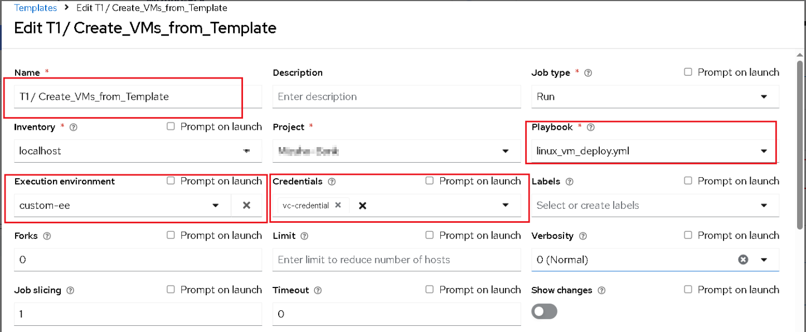

- Create the second playbook,linux_baseline_apply.yml, content of playbook as below:
[admin@aap25-jw example-project]$ cat linux_baseline_apply.yml
- name: Add dynamic host from previous playbook
hosts: localhost
gather_facts: false
tasks:
- name: Add VM to dynamic inventory
ansible.builtin.add_host:
name: "{{ vm_ip }}"
groups: provisioned

- name: Apply baseline configuration
hosts: provisioned
gather_facts: true
become: true

tasks:
- name: Ensure pwquality minimum length
lineinfile:
path: /etc/security/pwquality.conf
line: 'minlen = 14'
create: yes

- name: Set PASS_MAX_DAYS to 30
replace:
path: /etc/login.defs
regexp: '^PASS_MAX_DAYS\s+\d+'
replace: 'PASS_MAX_DAYS 30'

- name: Set PASS_MIN_DAYS to 1
replace:
path: /etc/login.defs
regexp: '^PASS_MIN_DAYS\s+\d+'
replace: 'PASS_MIN_DAYS 1'

- name: Update system-auth pwquality line
replace:
path: /etc/pam.d/system-auth
regexp: '^password\s+requisite\s+pam_pwquality\.so.*'
replace: 'password requisite pam_pwquality.so local_users_only'

- name: Add pwhistory to system-auth
lineinfile:
path: /etc/pam.d/system-auth
line: 'password requisite pam_pwhistory.so remember=13 use_authtok'
insertafter: '^password\s+requisite\s+pam_pwquality\.so.*'

- name: Update password-auth pwquality line
replace:
path: /etc/pam.d/password-auth
regexp: '^password\s+requisite\s+pam_pwquality\.so.*'
replace: 'password requisite pam_pwquality.so local_users_only'

- name: Add pwhistory to password-auth
lineinfile:
path: /etc/pam.d/password-auth
line: 'password requisite pam_pwhistory.so remember=13 use_authtok'
insertafter: '^password\s+requisite\s+pam_pwquality\.so.*'

- name: Set faillock deny = 3
replace:
path: /etc/security/faillock.conf
regexp: '^#?\s*deny\s*=.*'
replace: 'deny = 3'

- name: Force root to change password on next login
command: chage -d 0 root

- name: Set journald storage to persistent
replace:
path: /etc/systemd/journald.conf
regexp: '^#?Storage=.*'
replace: 'Storage=persistent'

- name: Restart systemd-journald
service:
name: systemd-journald
state: restarted

- name: Ensure authpriv logging is configured
lineinfile:
path: /etc/rsyslog.conf
regexp: '^authpriv\.\*'
line: 'authpriv.* /var/log/secure'

- name: Ensure /var/log/secure exists with correct permissions
file:
path: /var/log/secure
state: touch
owner: root
group: root
mode: '0600'

- name: Ensure audit is installed
package:
name: audit
state: present

- name: Ensure auditd service is running and enabled
service:
name: auditd
state: started
enabled: yes

- name: Ensure /var/log/audit/audit.log exists
file:
path: /var/log/audit/audit.log
state: touch
owner: root
group: root

- name: Ensure /var/log/cron exists
file:
path: /var/log/cron
state: touch
owner: root
group: root
mode: '0600'

- name: Ensure /var/log/boot exists
file:
path: /var/log/boot
state: touch
owner: root
group: root
mode: '0600'

- name: Download and place yum repo file
get_url:
url: http://10.66.208.245/rhel810.repo
dest: /etc/yum.repos.d/rhel810.repo

- name: Validate yum repo
command: yum repolist
register: yum_output
changed_when: false

- name: Ensure chrony is installed and enabled
package:
name: chrony
state: present

- name: Ensure chronyd is running and enabled
service:
name: chronyd
state: started
enabled: yes

- name: Add cron job for secure log backup
cron:
name: Backup secure log
minute: 0
hour: 3
job: 'cp /var/log/secure /backup/secure.$(date +\%Y\%m\%d)'

- name: Add cron job for messages log backup
cron:
name: Backup messages log
minute: 0
hour: 3
job: 'cp /var/log/messages /backup/messages.$(date +\%Y\%m\%d)'

- name: Restart cron service
service:
name: crond
state: restarted

Create the second job template with name "T2 / Apply_baseline_for_provisioned" base on the playbook as below：
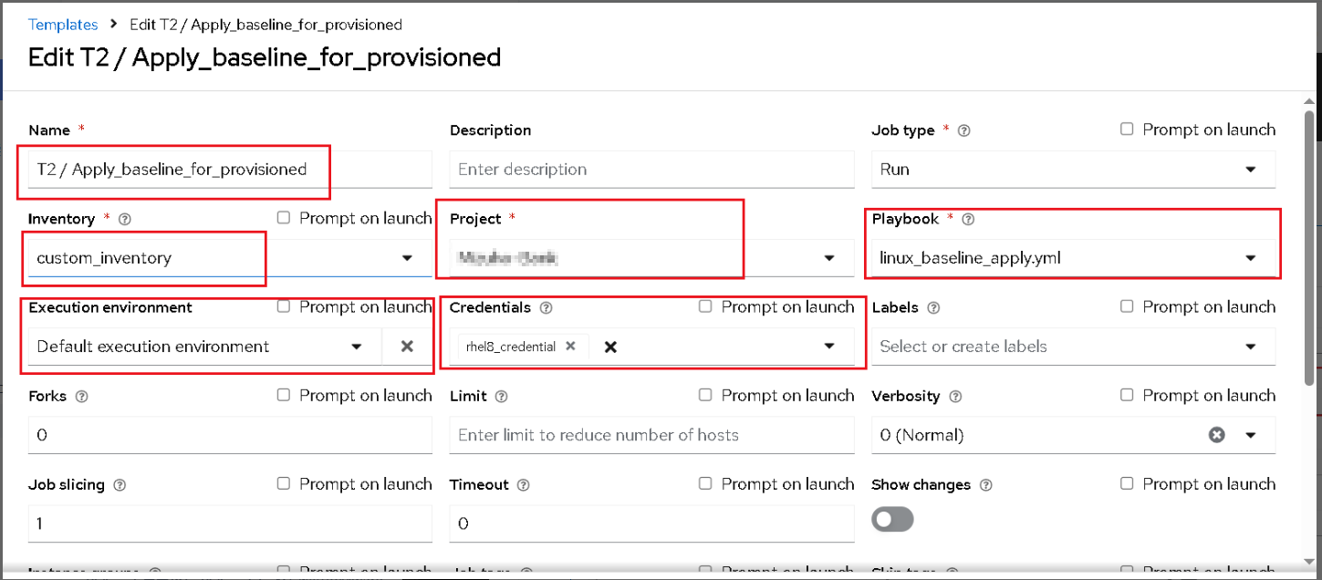

Note:
The inventory "custom_inventory" is actually an empty inventory, containing no hosts and serving only as a placeholder.
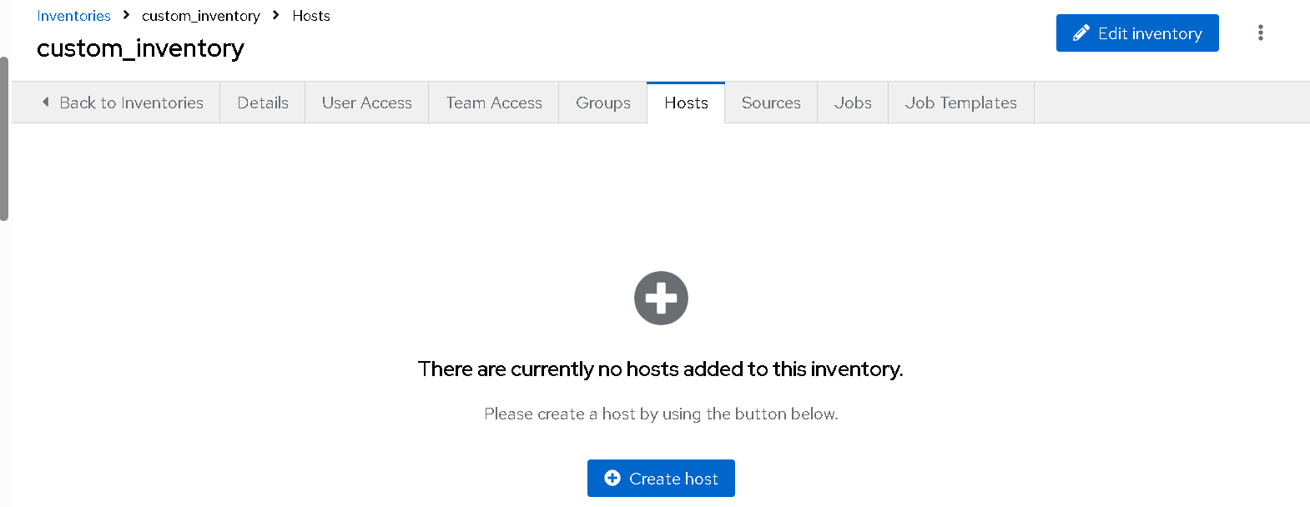

The credential “rhel_credential” is root password of the provisioned VM or vm template.

- Create the third playbook,linux_provision_notification.yml, content of playbook as below:
[admin@aap25-jw example-project]$ cat linux_provision_notification.yml
---
- name: Email Notification for VM provision result
hosts: localhost
vars:
data_center: ""
virtual_network: ""
vm_template: ""
vm_name: ""
vm_folder: ""
network_interface: ""
vm_ip: ""
vm_netmask: ""
vm_gateway: ""
vm_dns:
- ""
- ""

tasks:
- name: Send Email notification for provision result
delegate_to: localhost
community.general.mail:
host: smtp.gmail.com
port: 465
username: jerrywjl@gmail.com
password: YOUR_EMAIL_PASSWORD
to: jewang@redhat.com
subject: "VM Provision Complete Notification from Ansible Automation Platform"
body: |
VM Provisioning Complete!

Details:
- Data Center : {{ data_center }}
- Virtual Network : {{ virtual_network }}
- VM Template : {{ vm_template }}
- VM Name : {{ vm_name }}
- VM Folder : {{ vm_folder }}
- Network Interface : {{ network_interface }}
- IP Address : {{ vm_ip }}
- Netmask : {{ vm_netmask }}
- Gateway : {{ vm_gateway }}
- DNS Servers : {{ vm_dns | join(', ') }}

This message was generated automatically by Ansible Automation Platform.
subtype: plain

Create the third job template with name "T3 / Provision_result_notification" base on the playbook as below：
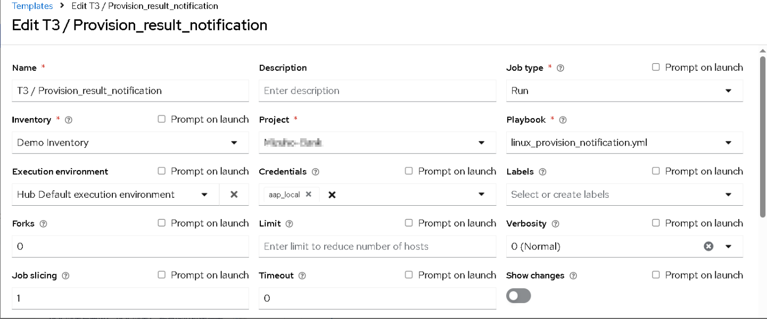

Note:
The inventory “Demo Inventory” is localhost, aap controller itself.
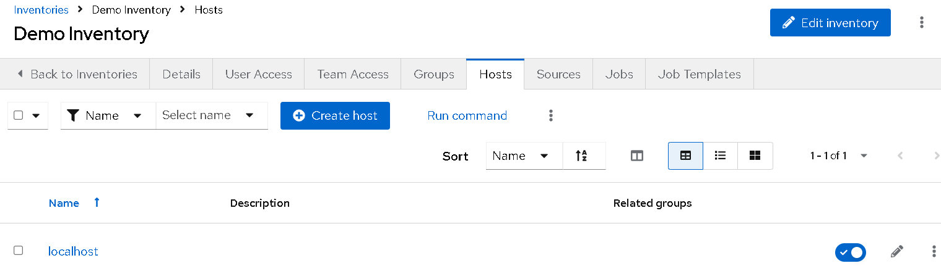

The credential “aap_local” is also localhost, aap controller itself.
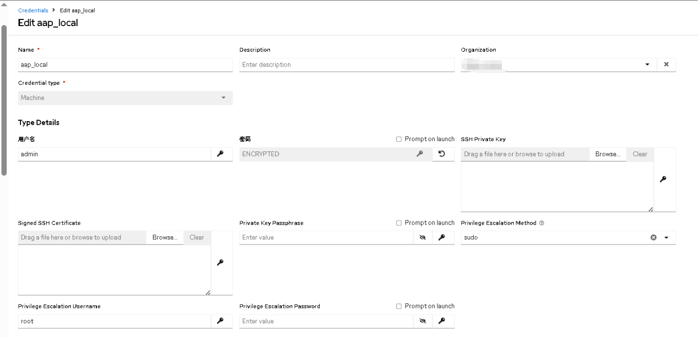

- Create the workflow job template with name “Linux_VM_Provision_with_Baseline_apply”, which is consisted of Job template T1-T3 we just created.
On AAP UI the process of workflow job template is as below:
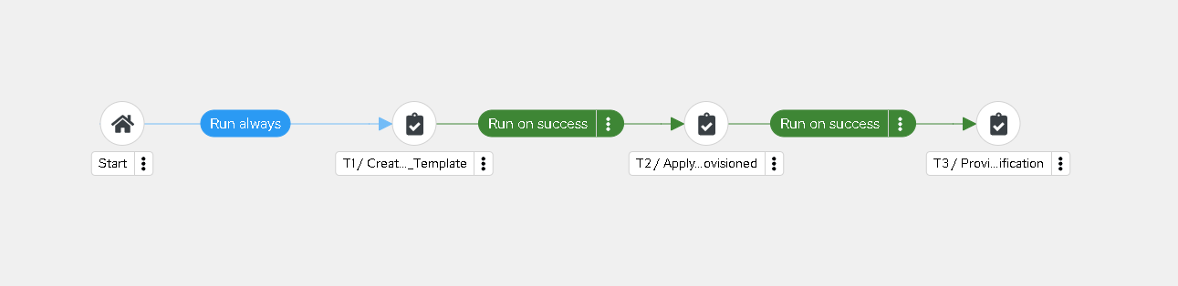

- Create a couple of survey on the workflow job template as below, based on my Lab env.
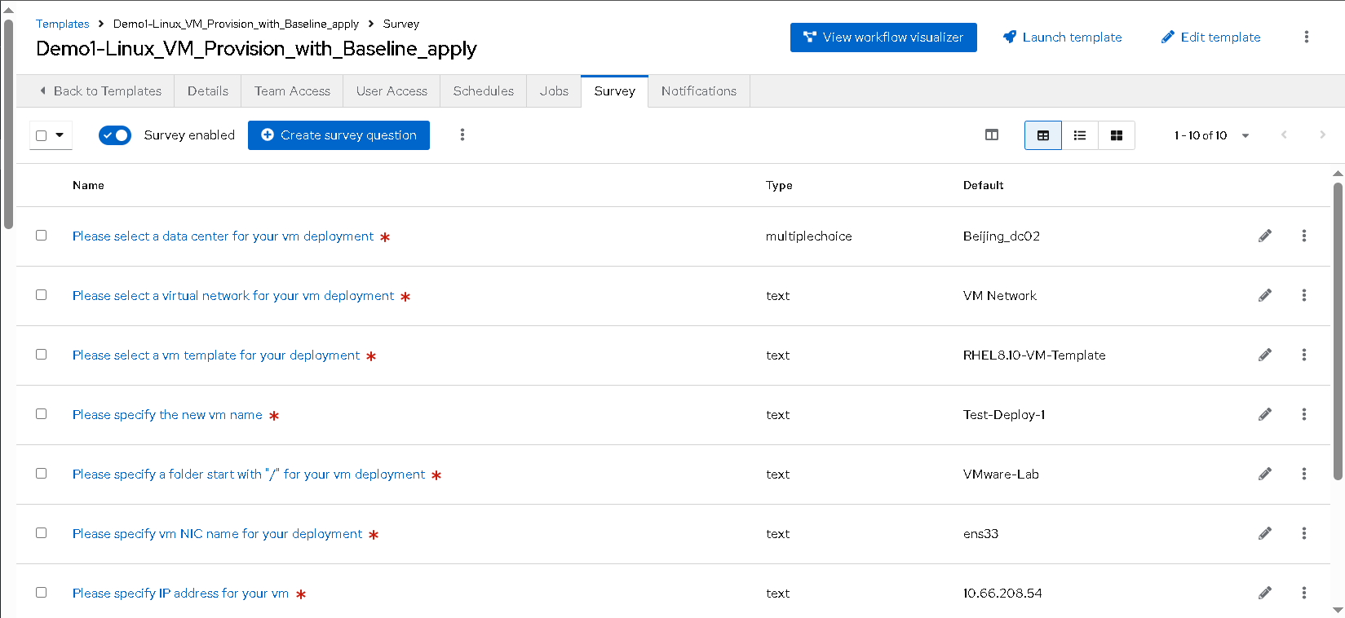
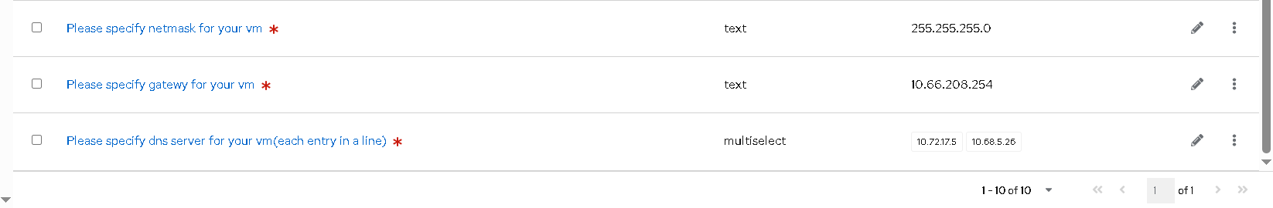

- When launch the workflow, you will need to input variables with survey above.
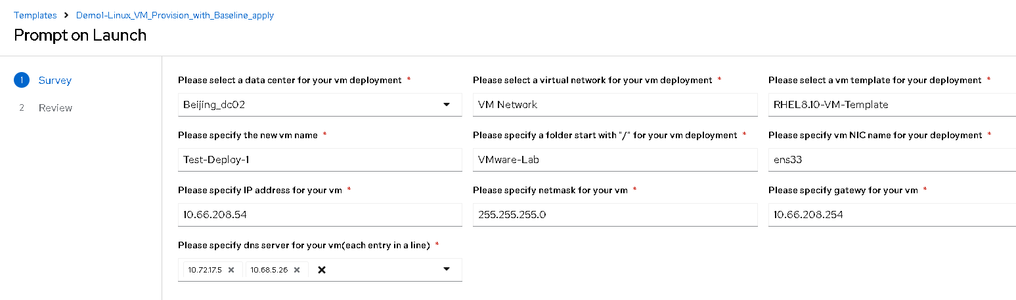
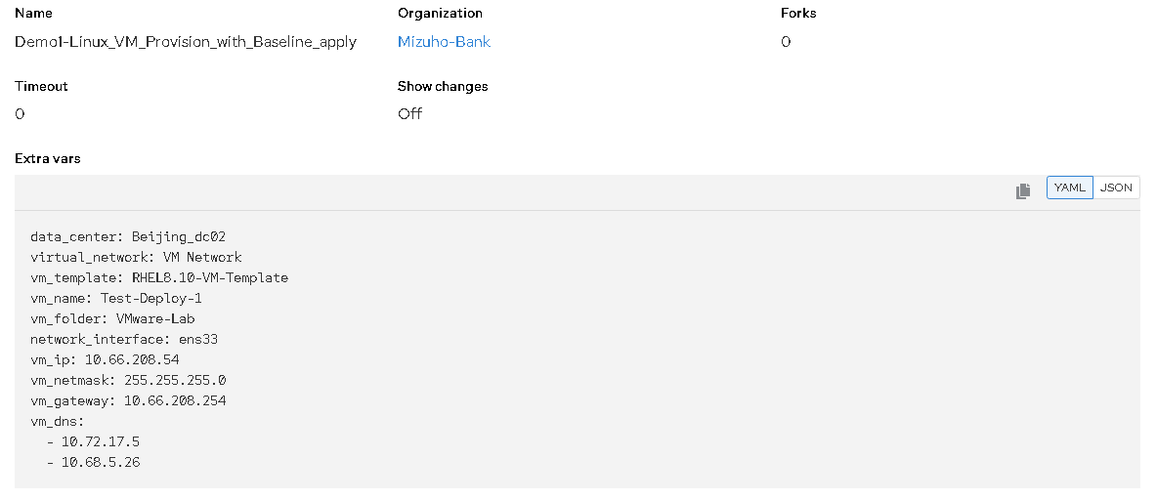

- Enable notifier on the workflow as below:
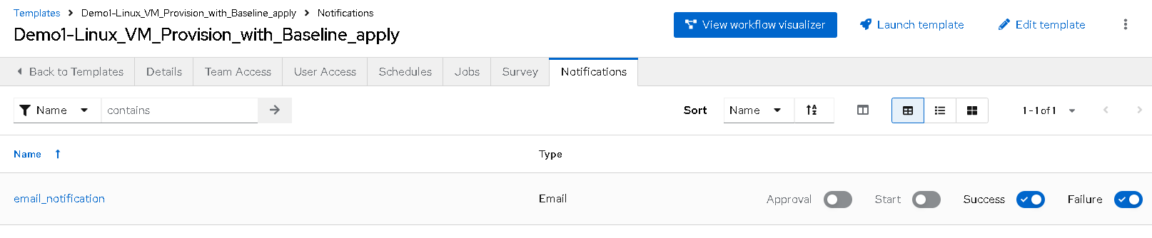

- After the workflow running successfully, you will get the email notification about the result like below:
